Project Scope and Outline Plan

Digital Pass Wallet for Android  
Diyan Komitov – 201522509

# Overview

As we have progressed into the digital age, more and more businesses have turned away from using paper-based tickets and physical loyalty cards. With the launch of IOS6 in 2012, Apple launched the Passbook app, later renamed to Apple Wallet, which changed the landscape by introducing a common place for users to keep all their different tickets, boarding passes, loyalty cards and more. Also, while Apple has had this functionality since 2012, Google has been slow to introduce a similar system for their Android operating system, only recently starting to introduce such features. Moreover, while Googles version of Wallet is still in its infancy, Apple’s PKPass file format is well established and used by many companies. The fact that it is so widely used has spawned several Android apps that attempt to replicate Apple Wallet’s passbook functionality.

This project will aim to create a digital pass wallet for Android which not only replicates current applications but also tries to improve upon them. Users of the application will be able to add new passes in several different ways. These include opening a PKPass file or scanning a QR code that downloads a PKPass file. Furthermore, if users do not have a PKPass file, they will be able to create a pass by filling out a form. In that case, the pass’ barcode can be generated in three different ways. These are either scanning a barcode to be copied, copying a barcode from a screenshot or some other image, or generating a barcode by giving it data to hold. Lastly, the user will be able to copy an NFC based card and use their phone instead.

Once a pass has been added, it will be displayed on the main screen of the application alongside any other passes. Passes will be sorted depending on their category, such as event ticket and loyalty card. If a pass contains an event time, such as for tickets and boarding passes, a notification will be sent to the user close to the time of the event. This notification will persist on their lock screen until the event has passed. Furthermore, for certain types of passes, mainly loyalty cards, users will be able to add several locations at which they would like a notification to be sent. These notifications, when pressed, will open the application and take the user directly to the pass corresponding to that notification.

Finally, users will be able to create an account which will allow them to store their passes in a database. They will then have the ability to access their passes from a different device and serve as a backup in case of loss of data. The application will not require access to the internet as the database will only be used to sync data when a pass is changed or added, and the app will store all pass data locally All user and pass data will be encrypted to ensure security.

# Objectives

## Basic – Required minimum functionality

* The user can add new passes by opening a PKPass file.
* The application can display all different kinds of passes and sort them based on type.
* The application can send notifications to users close to event time and near a location.

## Intermediate – Fleshed out functionality

* The user can add new passes by filling out data and generate barcode by scanning, copying from an image, or entering barcode data.
* The user can also add passes by scanning QR code that downloads a PKPass.
* Application UI is fleshed out to be attractive and user-friendly.

## Advanced – Bonus features

* The user can create an account and store their passes on the cloud.
* Ensure data is encrypted and secured.

## Extra – Only if there is extra time

* The user can add NFC based passes.

# Survey of Related Work

## Apple Wallet

Apple Wallet (initially called Passbook) is the originator of the digital wallet, and the PKPass file format was created specifically for it. This application is what this project draws most inspiration from and is trying to recreate. Apple Wallet and more importantly the PKPass file documentation will have to be studied so that data can be extracted from it to create a pass.

## WalletPasses

WalletPasses is the highest rated passbook application for Android on the Google Play Store. It is one of the first passbook apps for Android however it has not been updated since 2016. That being said It will be invaluable to study it and take inspiration from it in order to create the necessary functionality for this project.

## Pass2U Wallet

Pass2U Wallet is the second highest rated passbook application after WalletPasses, the big difference being that it is regularly being updated. It has features that go beyond those of any of its competitors such as the ability for users to create and use custom pass templates. However, these extra features, as well as the fact that it features advertisements, make the application seem a bit bloated and not as streamlined as Apple Wallet. It would be beneficial to study this application in order to avoid making the same mistakes that Pass2U Wallet might have made.

# Methodology

The first stage of the project will be gathering requirements from potential users and analysing them to adjust or add to the project specification that is outlined above. Using that information, requirements and design documentation will be created which will be followed during development to stay on track. As development progresses the requirements and design will be adjusted, some things might be given higher priority if deemed more important and some might be dropped entirely depending on the situation.

Furthermore, during the initial stage, a prototype system will be created. This prototype will serve as a vehicle to learn Android development as well as to create the basic requirements of the system. This prototype will then be refactored, or potentially redone from the ground up, and serve as the basis of the application.

The application will continuously be tested with unit tests and refactored as features are added and changed to ensure they are working correctly and are not compromising the rest of the system. When a significant feature is completed, it will also be manually tested and debugged if necessary.

# Project Evaluation

The application will be evaluated by potential users. They will be asked to complete specific tasks within the application and will be asked to give a rating for several factors of the application such as usability, attractiveness and more. They will also be asked to comment on the application generally and point out any areas that could have been improved upon or changed. Finally, they will be asked if they can see themselves using this application going forward. All this data will then be compiled and analysed when evaluating the success of the project.

Furthermore, the finished product will be compared with current passbook apps including Apple Wallet, to see how well it implements certain features, what it does better and what it does worse than its competitors. All of this should form a sound basis for evaluating the project.

# Project Plan

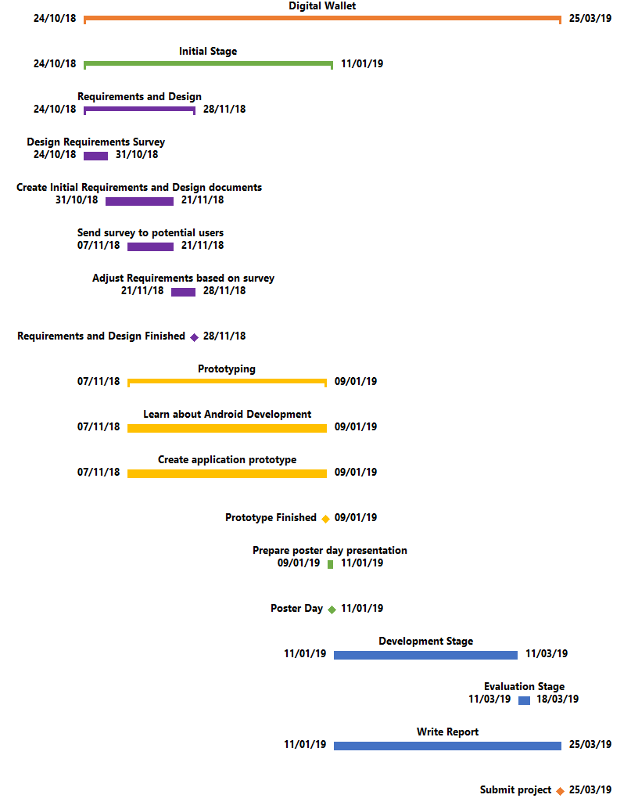

# Marking Scheme

The marking scheme chosen for this project is Software Development Based since the focus of the project will be to create the digital wallet application.

# Supervisor Comments

Diyan has made a good start to his project and has so far a good appreciation of what the project entails and where the challenges lie.